**CS 445 – Week 2 – Assignments #1-3**

**Matt Hartigan**

**18-May-2019**

**Assignment 1**

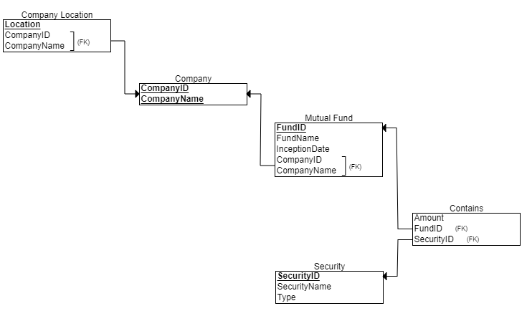

**Assignment 2**

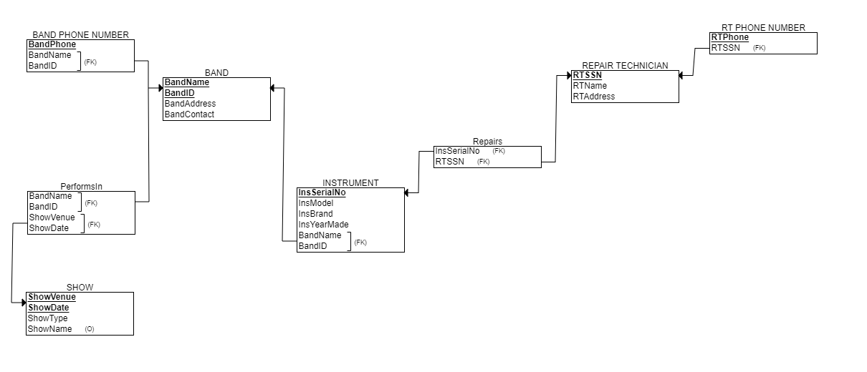

**Assignment 3**

